2.71: a) Travelling at 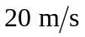, Juan is from the spreader when the brakes are applied, and the magnitude of the acceleration will be 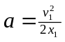. Travelling at 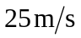, Juan is from the spreader, and the speed of the car (and Juan) at the collision is obtained from

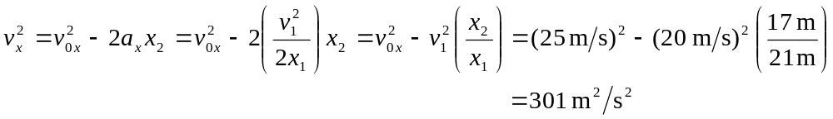
and so 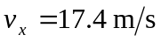.

b) The time is the reaction time plus the magnitude of the change in speed 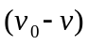 divided by the magnitude of the acceleration, or

